# SQL Statements – Hands on Document

**Pre-requisites & Instructions:**

* You are required to normalize the Specified Screen and create the required tables

1. Convert the below ER diagram to tables in database

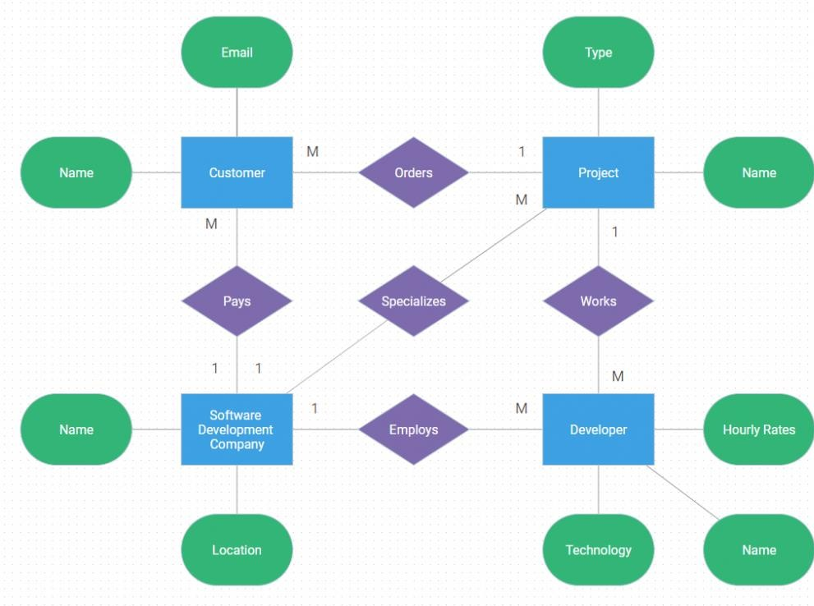i.

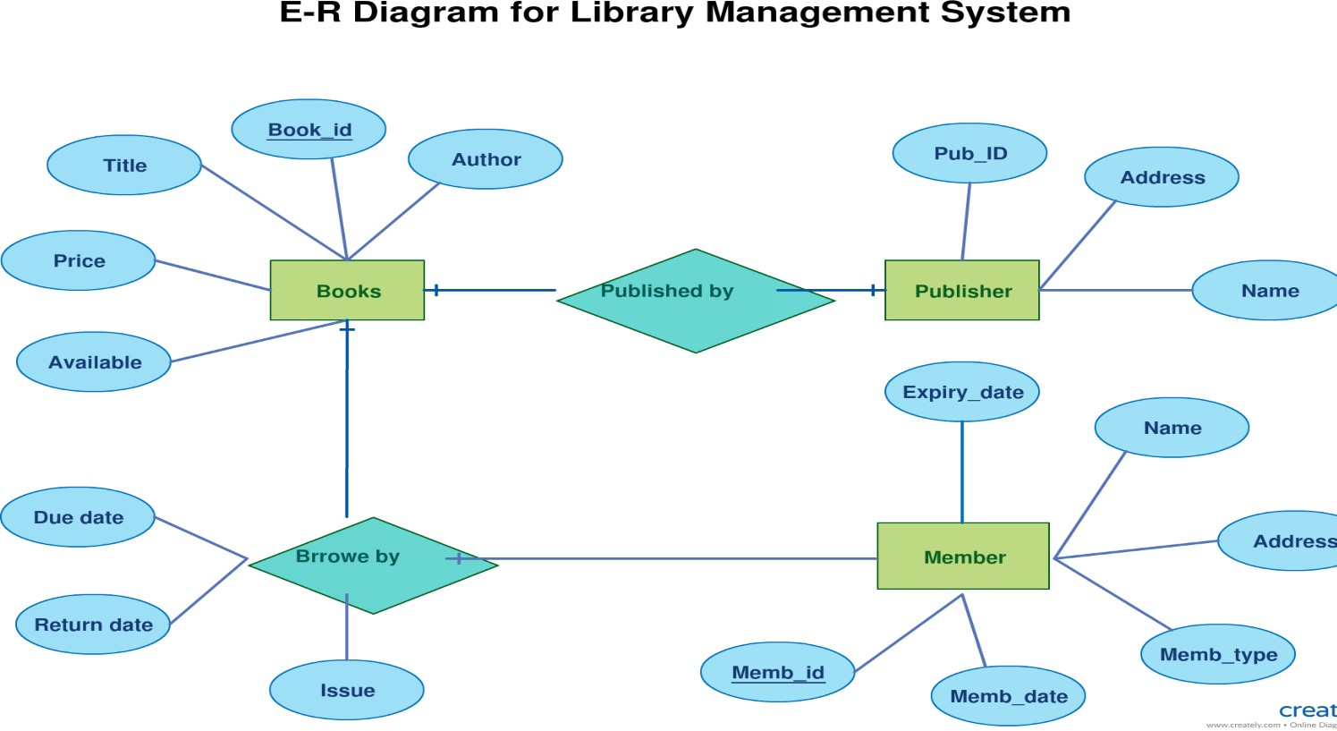ii.

1. Find the sample screen

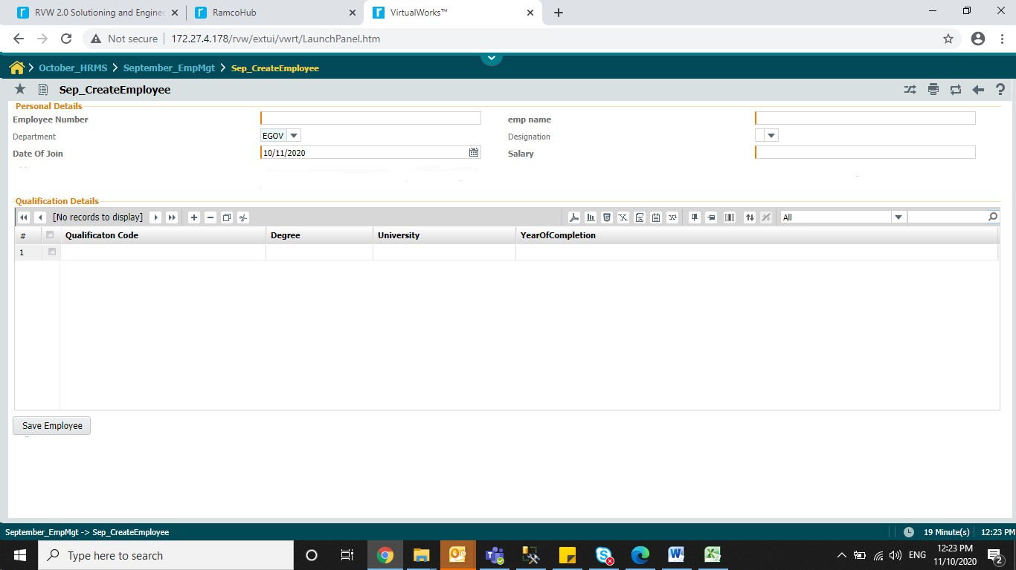

1. Create appropriate tables to store the data represented in the above screen

Create related Master tables and Transaction tables.

2. Create Primary Key and Foreign Key constraints by altering the table and adding the constraints.

3. Create a Order table with given columns OrderId ,ProdName, Description, OrderDate, Quantity with below criteria

* 1. OrderId should be autoincremented
  2. ProdName should not be null
  3. OrderDate should be current date
  4. Quantity should be greater then Zero